与童话王国的美丽邂逅
————挪威卑尔根大学交流后感
2014年春，我很幸运地地被选为我们学院第一批也是第一个赴挪威卑尔根大学交流的学生，时长一个学期。我从起初惴惴不安地来到这个陌生的国度，到后来一发不可收地爱上了这里的景色、人文，还有现在仍在交流、可以推心置腹的国内外朋友，以至于我们有了明年再度相聚欧洲的美丽约定。



一、旅游篇
无愧于连续8年蝉联联合国调查报告的全球最适宜居住的国家，美丽的峡湾风光足以让你窒息。 挪威国庆节期间，和闺蜜从卑尔根一路向北，不断变化的晶莹雪山、郁郁葱葱的森林、荡人心魄的湖泊、壮阔的平原夹杂在挪威典型的彩色房子里，我沉醉了！和煦的阳光透过列车的窗户，洒在脸上的画面成为记忆永恒的定格。


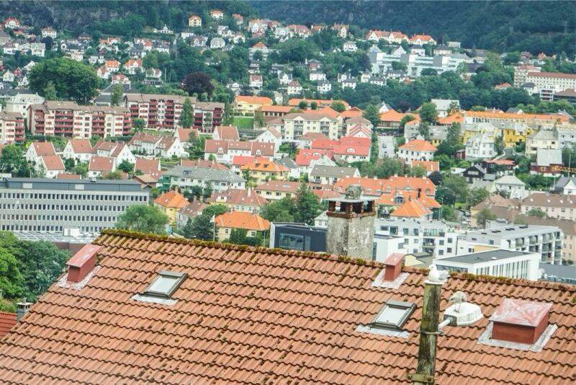
除了久负盛名的峡湾，卑尔根的鱼市也一直为人们津津乐道。里面各种海鲜产品让我眼界大开，我去的时候还不是露天的，不过室内的挪威大叔的盛情推销、免费品尝也让我过了把海鲜瘾。

另外去卑尔根交换的同学一定不会落下的地方就是和伙伴们一起爬Fløyen。我和我要好的波兰两美女、台湾闺蜜、还有挪威小哥们一起浩浩荡荡地开始了我人生第一次真人hiking。 蜿蜒曲折的山路有了小伙伴们的说说笑笑，瞬间轻松了些，纯净清新的空气和蓝天白云也把视觉效果拉伸到了极致。我咬咬牙，径直走到了峰顶，眼前是一片银装素裹的冰雪世界，我和俏皮的小伙伴们一起留下了属于自己的mark。 就在峰顶，我们看到了蔚蓝的大海和整个卑尔根城市！
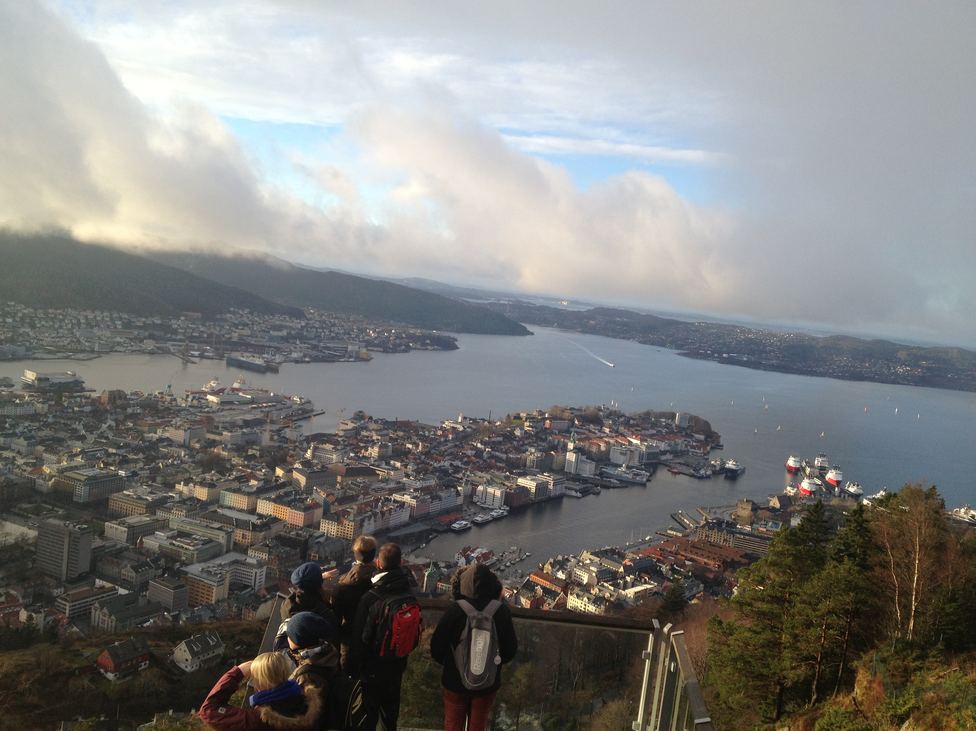

当然卑尔根还有一些其他景点，如Bryggen、 格林小屋等。更值得一提的是，挪威因为不是欧盟国家，只是申根国家，所以对欧洲其他国度心仪已久的同学，不失为一次美妙的体验。我就和人大法学院的师兄以及台湾闺蜜在复活节期间去了意大利的罗马和威尼斯，还有最小的国家梵蒂冈。


二、学习篇
挪威的选课、学习、备考经历是我22个年头里最美好的课程经历。由澳门的朋友推荐，我选了一位有着丰富仲裁经验的Larry Bakken 。犹记得为了准备这门课程，我翻读了多本关于介绍国际仲裁法的书籍，课堂上我积极参与，在和教授互动的同时，也注意倾听来自欧洲其他国家的同学发言，思考他们的立场以及法律思维的习惯。最后的评分是综合性的，根据平时的课堂参与度，模拟仲裁法庭的表现，期中essay，以及期末考试成绩。确实只有这样全方位、多角度的评分体系，才能真正激发学生的学习兴趣以及他们探索法律的奥秘，并且也能在法庭的团队合作和针锋相对中锻炼法律逻辑能力与思考能力。

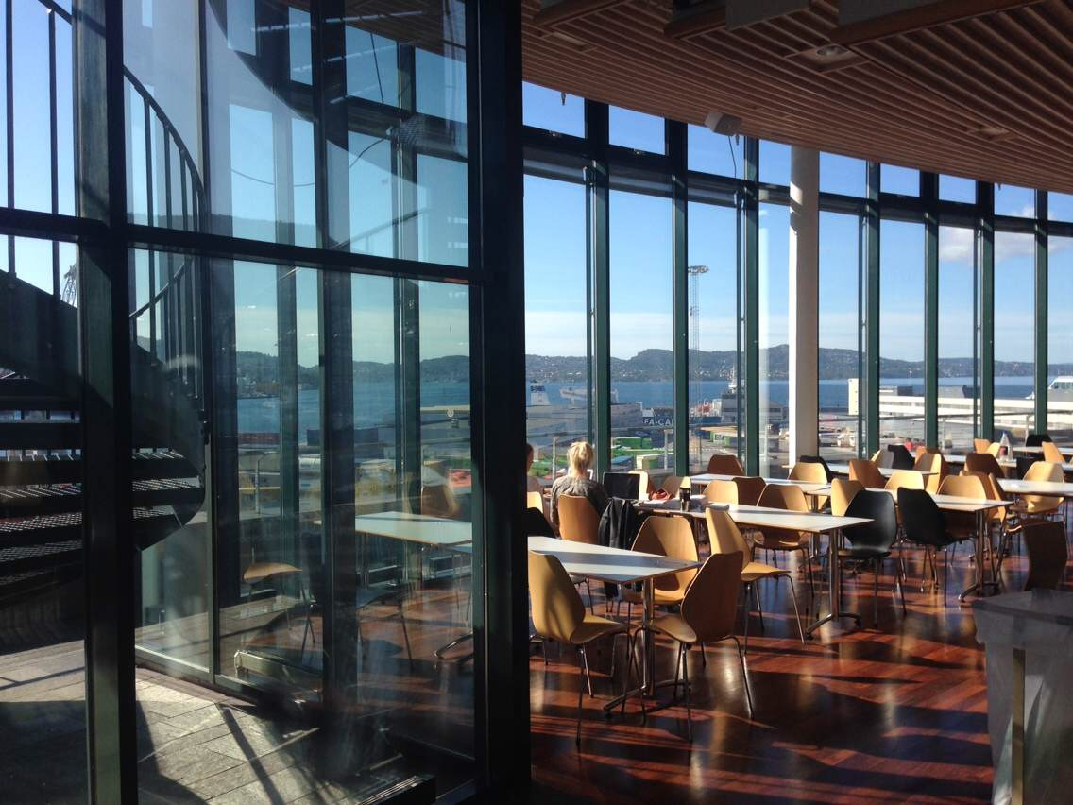
由于表现优异，我得到了卑尔根法学院的采访，并且采访内容也刊登在了法学院网站首页上，为此附上链接，http://www.uib.no/en/node/76874 ，希望能帮助以后有志于去挪威交流的同学更好地了解卑尔根。

Beyond my expectations
The cultural shock hasn’t stopped since the first day I arrived here.
Name: Xue Ying
Age: 21
Home University: China University of Political Science and Law
Nationality: China
Exchange programme: Bilateral agreement
Duration of your stay: One semester
- Why did you choose to study at the University of Bergen?
From an objective perspective, it is because UiB and my home university established an exchange programme in 2011. This programme went into effect this year and I was nominated by my university to participate. From a subjective perspective, I know that the University of Bergen is quite a famous university in Norway, especially with many International students pursuing their academic studies here, and it could offer me wider and deeper insight into law and other aspects. Moreover, I am drawn to the beautiful scenery of the fjords and the nice humanistic environment here.
- What is your impression of Bergen compared to what you expected?
It is totally beyond my expectations. First of all, people here are very nice and helpful. Whenever I have a problem and ask a Norwegian or anyone else, they are so friendly and help me. I never feel lonely or homesick. Besides, the professors in my classes, like Introduction to Copyright law, are so nice and knowledgeable, and they usually inspire me to think differently and more deeply. And also, the natural surroundings are amazing.
- Which are the main differences between your home country and Norway in terms of being a student?
The cultural shock hasn’t stopped since the first day I arrived here. For one thing the faculties of the university are scatted around in the city, mingled with residence areas, shopping zones, restaurants and so on. This provides students a comfortable and free environment to study. In China, we have university-specific zones, as there are also shopping areas, residence districts, and so on. This intense structure with a vast number of university buildings together has its advantages, such as intensifying the academic atmosphere and increasing the opportunities to communicate between schools, but it also puts more study pressure on students and reduces their opportunities for entertainment and real social life.
Also, without a doubt, the living standard here is much higher than in China, especially in the areas of food, service and public transit.
The Norwegian government obviously puts great emphasis on education because tuition is practically free here. But in China, although the government underscores the importance of education, students are still required to pay tuition fees to study beyond the nine-year compulsory education.
The forms of entertainment here are mainly parties, skiing, travelling. In China, partying is not included in our forms of entertainment, even though some people might occasionally do that. We tend to sing in the karaoke bars, go to the amusement parks, visit places in other provinces and so on.
- In your opinion, what is the most important academic outcome you have gained from your time in Bergen?
The English language skills. To have the opportunity to speak English in daily life with other international students.
- What are your future plans?
I will pursue my master’s degree in UCL specializing in International Economical
Law.
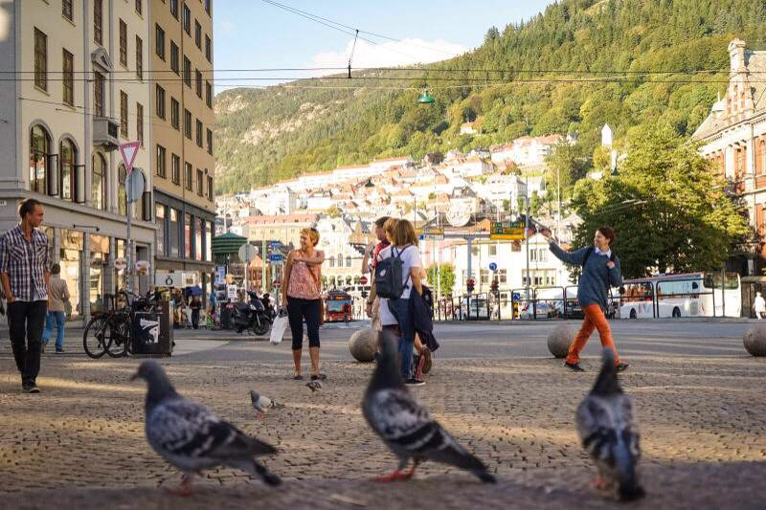

三、生活篇
挪威有很多超市，如Rema 1000, KIWI, RIMI,等等；挪威的物价几乎为欧洲之最，当然这也与它的高福利体系相呼应，水果、蔬菜价格奇高，即使是挪威本土的学生或者是欧洲其他国家，如我的奥地利朋友也称，挪威的生活水平超过了他们的budget。 正因如此，半年多的时间竟直接把我从一个不知家务的“白丁”变成了上得了厅堂下得了厨房的“女汉子”！我和好朋友经常会做cheese cake, oriel cake, carrot cake等各种蛋糕，还有做春卷、寿司等各国美食……所有这些记忆画面的串联，如一幕幕电影闪过脑海，让我禁不住又回想起“那些天和朋友一起做过的美食”了。


2010级法学院6班
薛 莹

